**Database Management System Report**

**Bigmouth: A restaurant recommendation chatbot**

**(UCS411)**

**Fourth-Semester**

**Submitted by:**

**(102153031) PRANAV KUMAR AGRAWAL**

**Submitted To:**

**Dr. Radhika Bansal**

**APRIL 2023**

**Index**

|  |  |  |
| --- | --- | --- |
| Sr. No. | Topic | Page No. |
| 1 | Title Page | 1 |
| 2 | Index | 2 |
| 3 | Introduction | 3 |
| 4 | ER-Diagram | 4 |
| 5 | ER to table | 5 |
| 6 | Normalization | 6 |
| 7 | SQL(mySQL) | 7 |
| 8 | Conclusion | 21 |
| 9 | References | 22 |

3.Introduction:

Bigmouth is an Interactive, user-friendly chat application.

User can find Restaurant’s, Restaurant menu, food items prices available in PATIALA using FACEBOOK.

User/Customer can find menu of restaurants available in PATIALA, just by using Facebook. Not only menu but also prices and can give feedback by Updating menu of restaurant.

Along with menu User/Customer can find Ratings of Restaurants (Overallrating) , Staff Rating of Restaurant(srating) , Cleanliness Rating of Restaurant(crating) and Food Rating of Restaurant(arating) also.

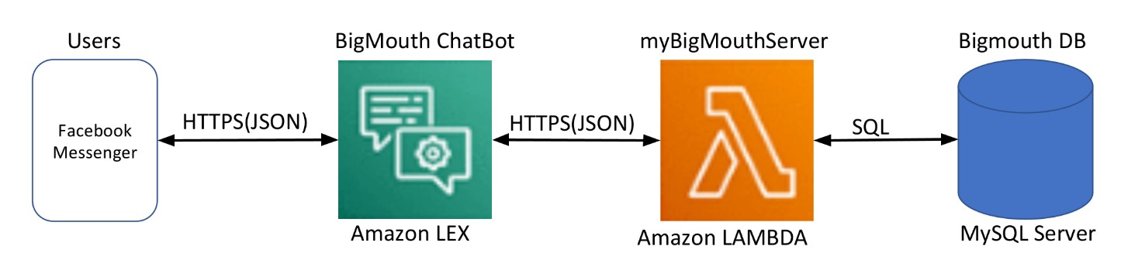

Figure 3.1 Layout of Application Bigmouth

Application Bigmouth uses AWS 3 services:

1.Amazon LEX

2. Amazon LAMBDA

3. MySQL SERVER (ON Amazon EC2)

Facebook Page Link:

<https://www.facebook.com/profile.php?id=100091719981771>

Facebook login details:

email: chatbot.test707@gmail.com

password: Shimito#2470

(NOTE: Please don’t use Thapar WIFI while login in Facebook)

4.ER – Diagram

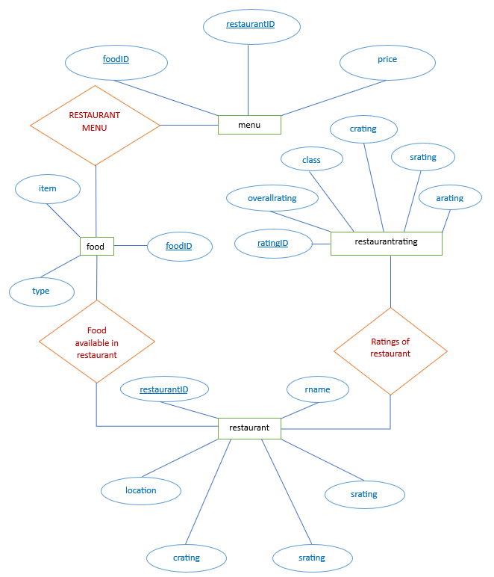

Figure 4.1 ER – Diagram of Bigmouth

5.ER to Table

menu

|  |  |
| --- | --- |
| FK  FK | foodID  restaurantID |
|  | price |

restaurant

|  |  |
| --- | --- |
| PK | restaurantID |
|  | rname  location  srating  arating  crating |

food

|  |  |
| --- | --- |
| PK | foodID |
| UK | type  item |

restaurantrating

|  |  |
| --- | --- |
| PK | ratingID |
|  | class  crating  arating  srating  overallrating |

Figure 5.1 ER to Table Diagram of Bigmouth

6.Normalization

1 NF (First Normal Form)

Condition: Each cell of a table should contain a single value.

Table “menu”, “food”, “restaurant” and “restaurantrating” are 1NF.

2 NF (Second Normal Form)

Condition: It is in 1 NF and each table should contain a single primary key.

Table “menu”, “food”, “restaurant” and “restaurantrating” are 2NF.

3 NF (Third Normal Form)

Condition: It is in 2 NF and there is no transitive dependency.

Table “menu”, “food”, “restaurant” and “restaurantrating” are not 3NF.

7.SQL (MYSQL)

(FRONT END)

**7.1.Selecting Data From Table in mySQL**

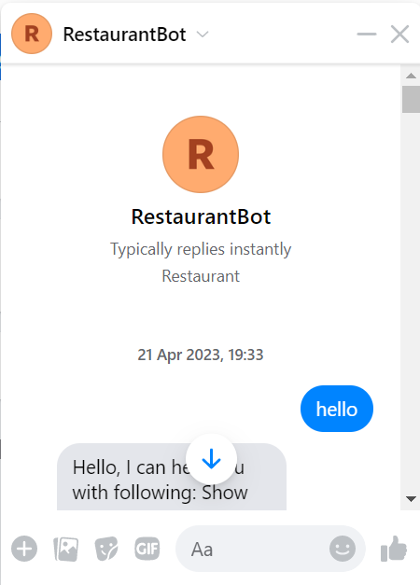 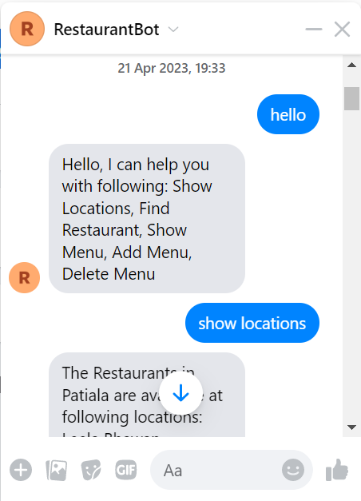

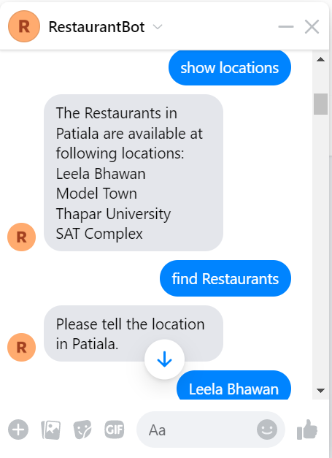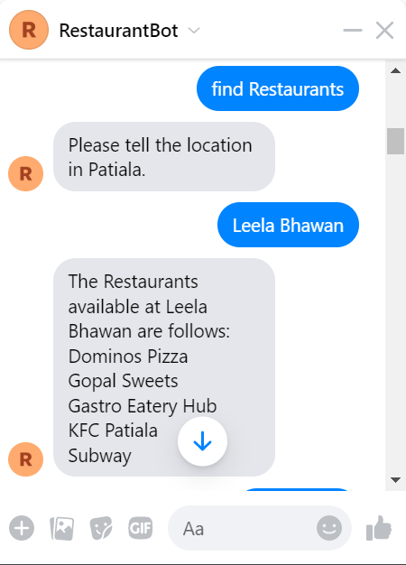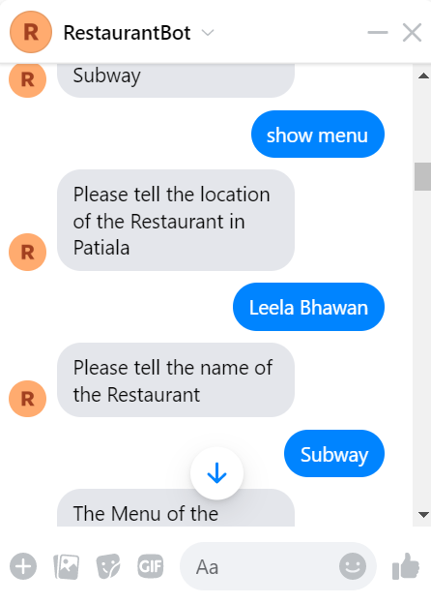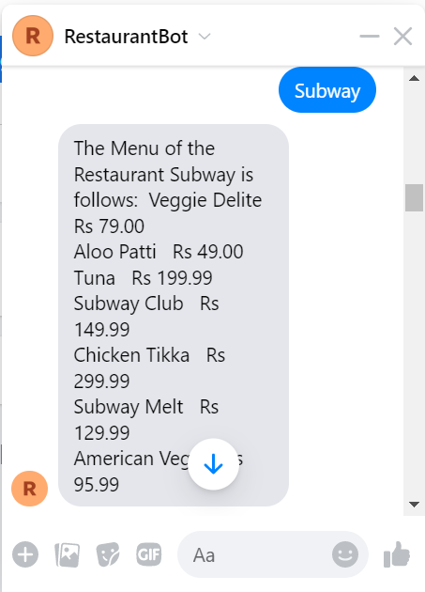

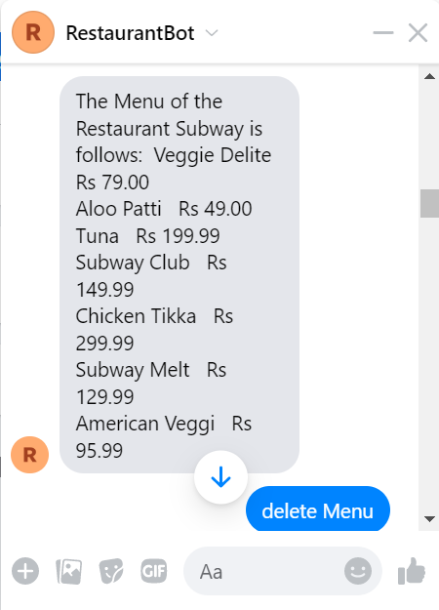

**7.2.Deleting Data From Table in mySQL**

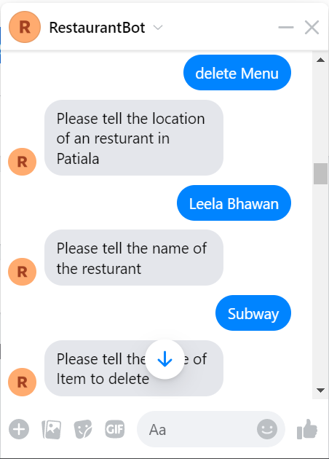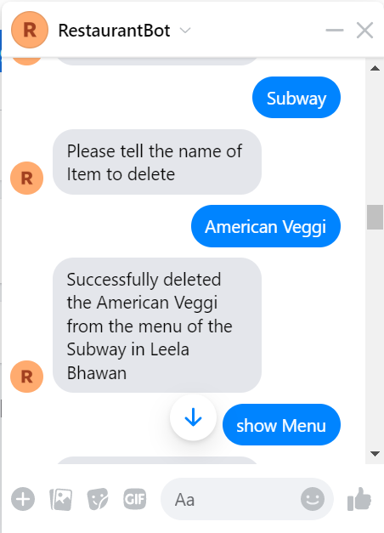

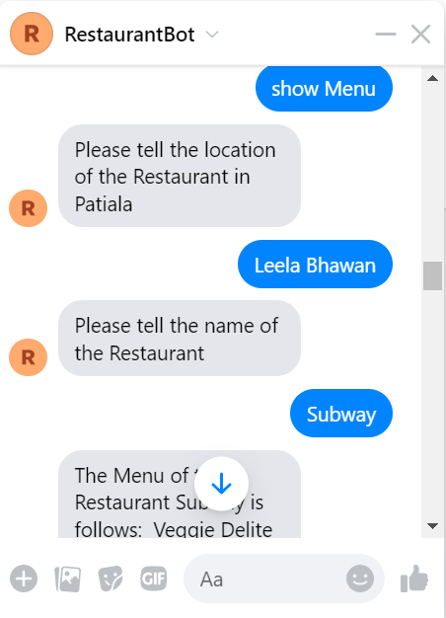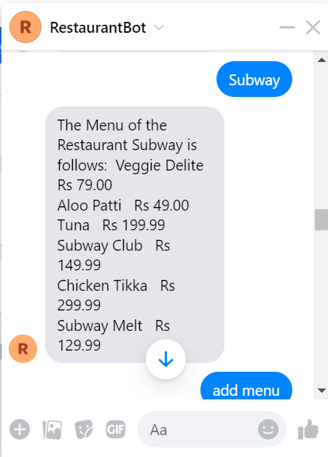

**7.3.Updating Data From Table in mySQL**

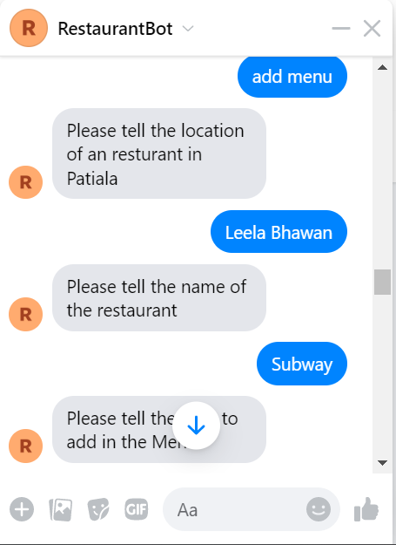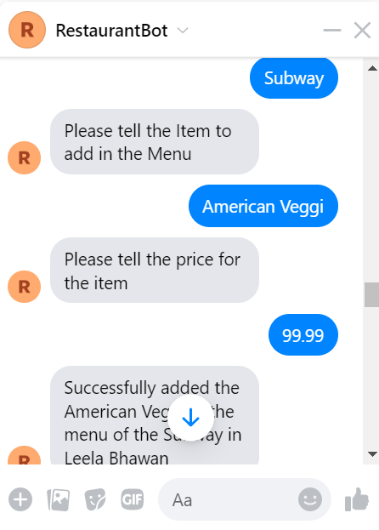

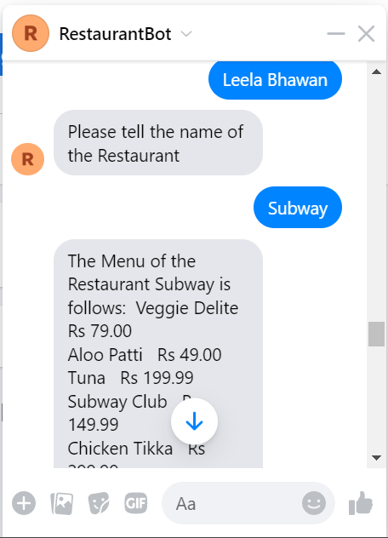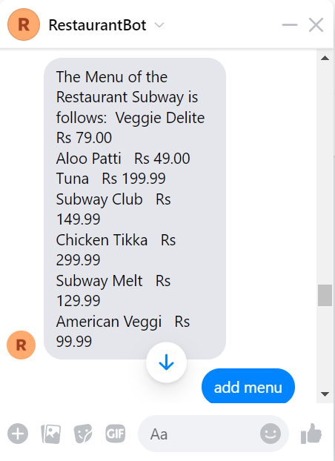

Back End (MySQL)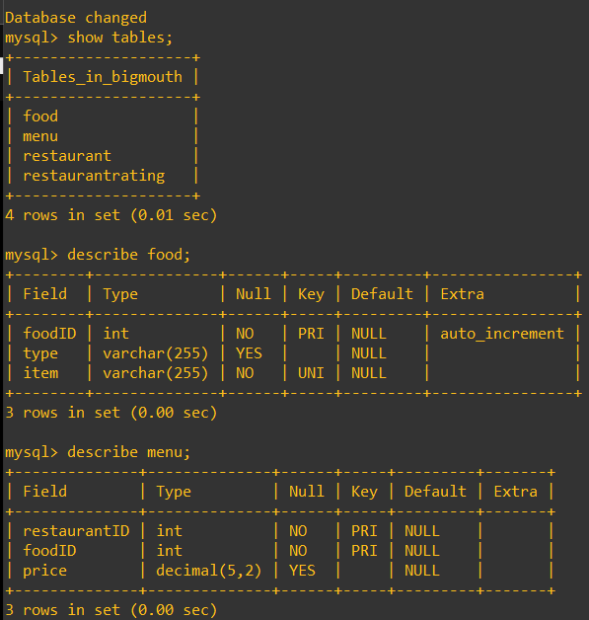

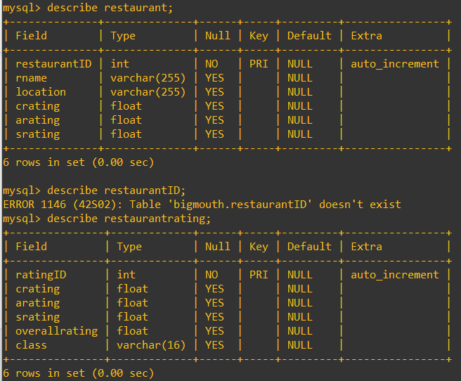

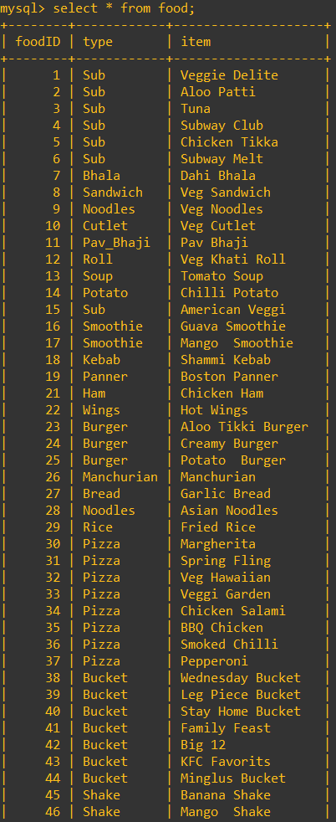 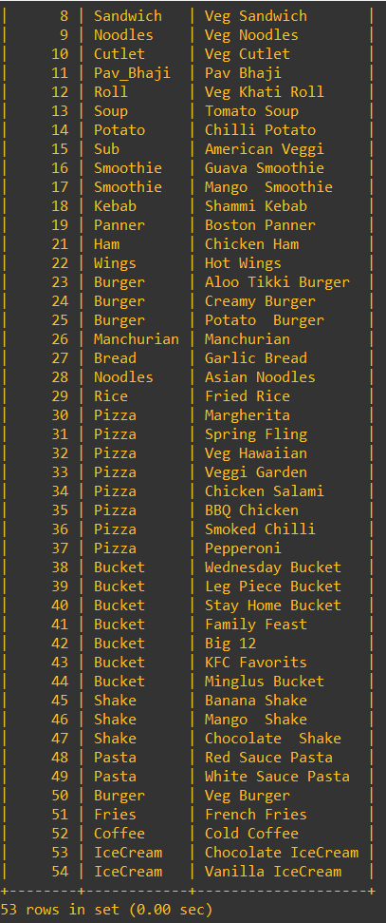

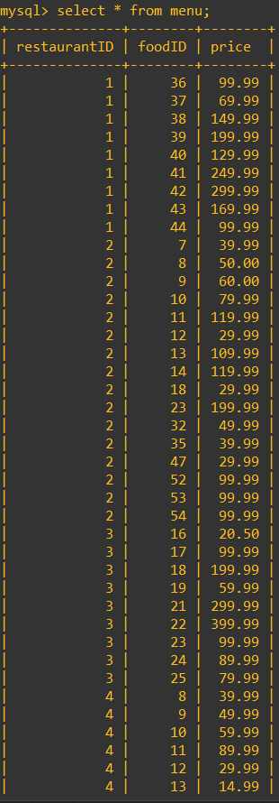 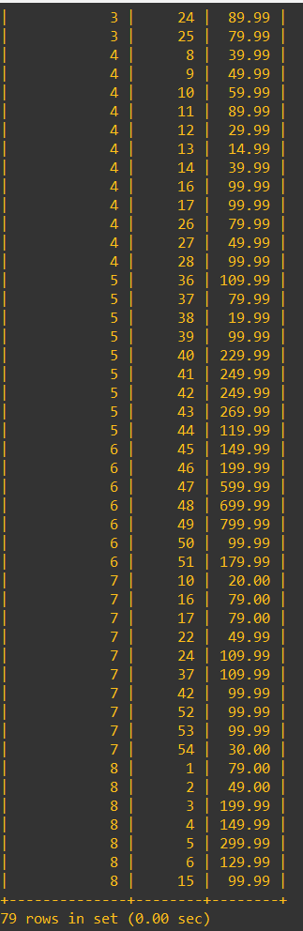

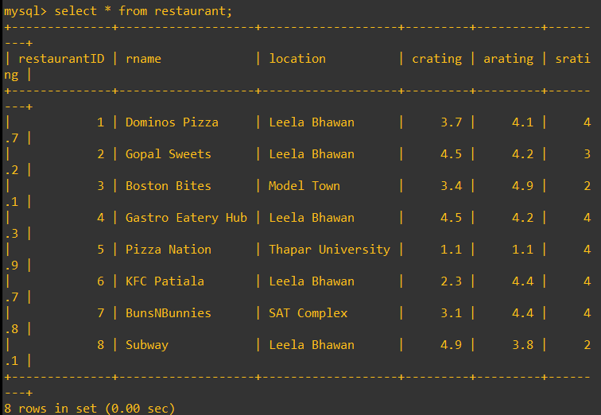

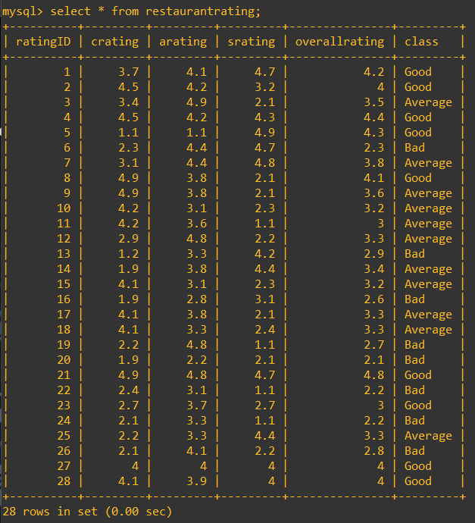

8.Conclusion

Bigmouth is User friendly, Facebook available chat application which uses AWS services to provide user Information about restaurants available in PATIALA.

As the application BIGMOUTH uses Cloud based platform (AWS), the application can be modified, accessed in many ways, like here Facebook or can be used on WhatsApp also.

User/Customer can find menu of restaurants available in PATIALA, just by using Facebook. Not only menu but also prices and can give feedback by Updating menu of restaurant.

Along with menu User/Customer can find Ratings of Restaurants (overallrating), Staff Rating of Restaurant(srating), Cleanliness Rating of Restaurant(crating) and Food Rating of Restaurant(arating) also.

Bigmouth uses KNN Algorithm, which gives precise ratings collected over vast raw data collected in systematic manner from User/Customer.

User/Customer can provide feedback by updating menu of restaurant and can update restaurants food item’s price. Along with this User/Customer can delete food item if its unavailable in restaurant.

As a Conclusion, Bigmouth is interactive and user-friendly application that uses mySQL as DATABASE and can be expanded in to various cities and towns.

9.References

1. https://en.wikipedia.org/wiki/Amazon_Web_Services

2. https://www.serverless.com/aws-lambda

3. https://en.wikipedia.org/wiki/MySQL

4. https://docs.aws.amazon.com/lexv2/latest/dg/what-is.html

5. https://aws.amazon.com/chatbot/

6. https://aws.amazon.com/rds/

7. https://docs.aws.amazon.com/AWSEC2/latest/UserGuide/concepts.html